WU HARDENING
With ubuntu server 22.0 TLS



Write By arctakano

*note: this write up i make from my experiment

Configure ssh
- Secure ssh from vulnerable and change some configure from file /etc/ssh/sshd_config to make cant vulnerable from the hacker. Here some configure you need it

PasswordAuthentication yes
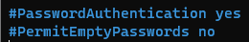

PermitEmptyPassword no


PermitRootLogin no
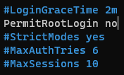

Protocol2
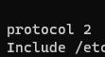

If all configure done, don’t forget to type “sudo systemctl restart ssh”

Apache2 webserver
- Make some configure to make output like normal webserver and some secure like SSL will help you. With this configure you can make one like this

- First we make some directory to make code in /var/www

- Use mkdir -p /var/www/your_domain to make the directory. Output will be like this
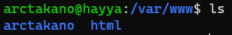
- Then to make the code just use sudo nano domain/index.html. Output will be like this.
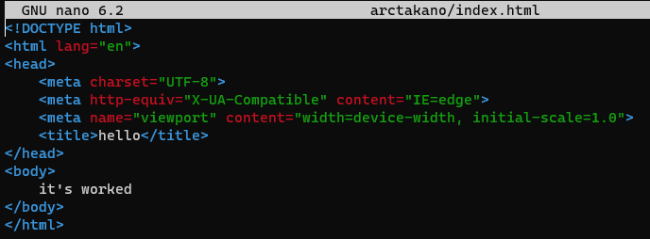
*note: whatever you use the code in index.html
- Last is to active the code using chmod -R 775. output will be like this
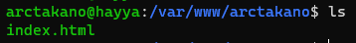

- Second, let’s make file configure in apache2

- Make some directory config, I used copy paste using cp command. Output will be like this
cp default-ssl.conf arctakano-ssl.conf*
- Then configure domain-ssl.conf. The set config is
ServerAdmin
ServerName your_domain.com
serverAlias www.your_domain.com
DocumentRoot /var/www/your_domain

If you have certificate ssl in ubuntu server*
SSLEngine on
SSLCertificateFile /etc/ssl/your_domain.crt
SSLCertificateKeyFile /etc/ssl/your_domainr.key
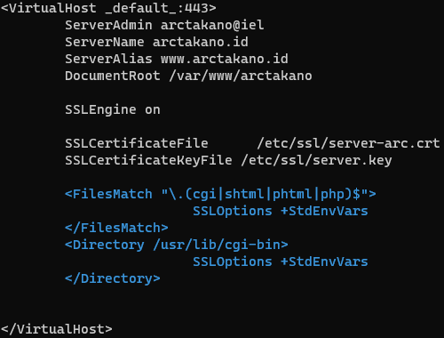
- If you done doing configure apache2 don’t forget to enable using a2ensite and sudo systemctl reload apache2. now you have you own server

- This is the last from apache2 is SSL. I just give you a script here hope you understand :)

openssl genrsa -out cakey.pem 2048
openssl req -new -key cakey.pem -out cacert.csr -config openssl.cnf
openssl x509 -req -in cacert.csr -out cacert.pem -signkey cakey.pem -days 3650
echo 01 > cacert.srlsaya | opsional

openssl genrsa -out server.key 2048
openssl req -new -key server.key -out server.csr -config openssl.cnf
openssl x509 -req -in server.csr -out server.crt -CA cacert.pem -CAkey cakey.pem -days 3650

Source certificate SSL from pak ali*

SSH Key Authentication
- Automatic login and secure with authentication, this job need 2 device or OS to make it. It have 3 type that’s ubuntu, puTTY, and windows. This authentication I using keygen

- First make one on another device then make one certificate ssh I will make from ubuntu, just follow the command

ssh-keygen -b 4096
cat .ssh/id_rsa.pub
ssh-copy-id ip address

Source from myself*

Output:

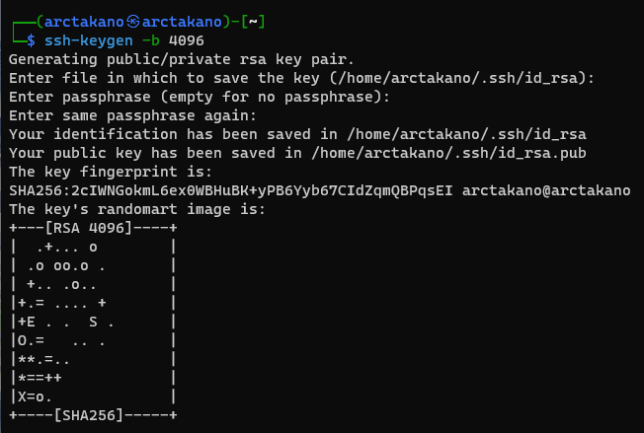
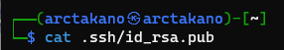
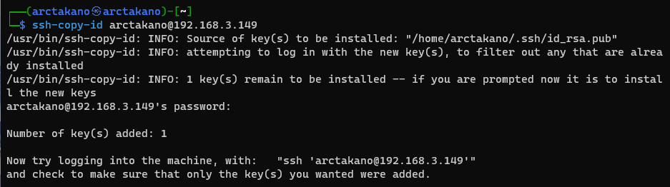

*note: command “cat .ssh/id_rsa” is looking the public key

- Second, you can ssh with third application using puTTY

- First input some data in PuTTY, then save it
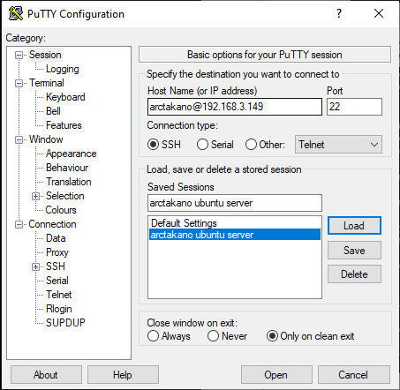

- If done, lets generate key with puTTYgen
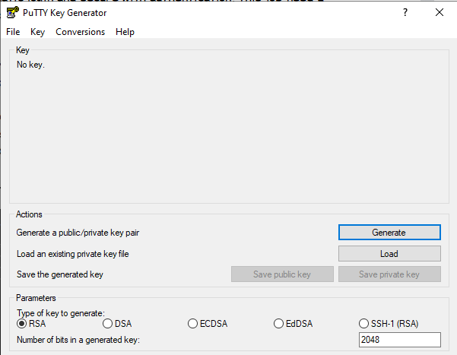
if all done with generate key, the output will be like this:
*note: don’t forget to save the public key in puTTYgen

- Now you can access the server without password

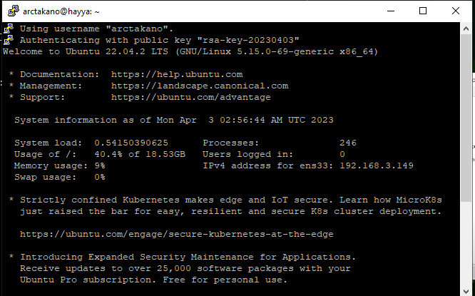

Last recipe from me, don’t forget to change ssh configuration if you want hacker don’t come to your server

Sudo nano /etc/ssh/sshd_config
PasswordAuthentication no
Sudo Systemctl restart ssh

Yeah, but don’t give to another. If someone want it just say ytta
Because this job I do is very hard to make

Thank you for reading this write up
Salam dari arctakano



